**Fold change search help.**

The goal of this search is to identify genes that are differentially expressed between reference and comparison samples. We’ve placed some dynamic help beside the search parameters to illustrate how your parameter selections ~~you are making will~~ affect the subset of genes that are returned by your search.

With this search you can identify genes that are greater than 2-fold up-regulated in a set of comparison samples compared to a set of reference samples. The search is ~~pretty~~ straightforward when comparing only one reference and one comparison sample. In this case, the search returns every genewhose expression value in the comparison sample, when compared to the value of the reference sample, meets the direction and fold change criteria. For example, if you choose up-regulated and 2 fold, then for each gene returned, the expression value in the comparison sample is at least 2 fold higher than in the reference sample. The complexity arises when you choose more than one reference or comparison sample. In that case, you have to apply an operation to the expression values of the chosen samples to generate a single value that can be used in the fold change calculation. The following graphic helps illustrate this concept.

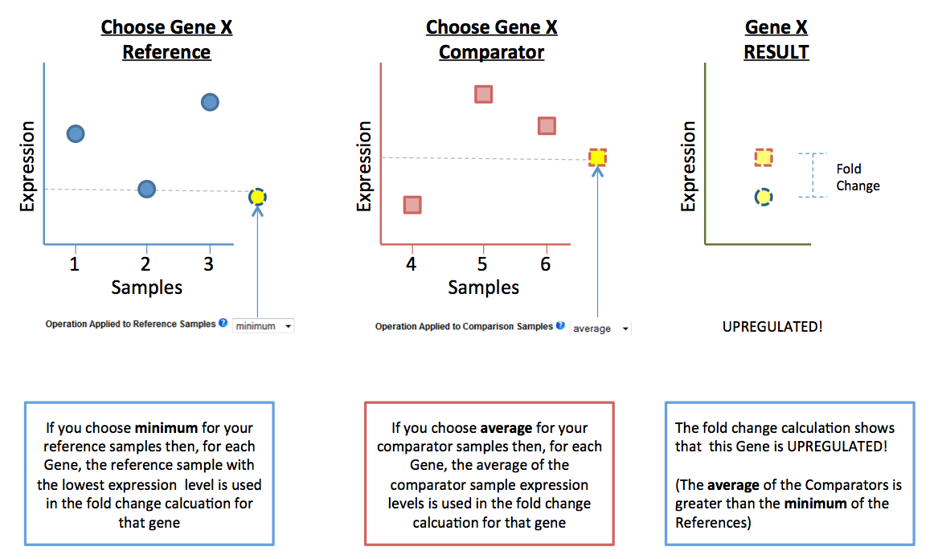

The take home message is that in order to calculate a fold change, we need to convert a set of values for the samples you select for reference or comparison to a single value for the calculation. This is done by taking the minimum value, average value or maximum value of the selected reference and likewise for the comparison samples.

Think carefully when choosing the direction and the operations ~~as~~ because you will get very different results depending on your choices. When you change the direction parameter, we set the default for the operations parameterto be the most inclusive so that the largest possible number of genes will be returned. For example, if you choose “up-regulated” for the direction parameter, we set the operations to the minimum reference value and the maximum comparison value.



In the above example (which we also provide for you on the search page) is an expression value in the comparison samples that is actually less than the value for any of the reference samples. This is an extreme example but makes the point that even though this gene does have samples among those that you selected that match your fold change cutoff, this may not be a gene you really want in your results.

Alternatively, the most restrictive search for the up-regulated direction is just the opposite … maximum reference and minimum comparison.



In this example, all the expression values in the comparison samples are up-regulated by at least the requested fold change compared to the reference samples.

You can also choose average as the operator. This is a good idea when you expect that the samples you have selected are essentially replicates of each other or you have reason to believe that their expression will be similar. Note that when you choose “up-or-down regulated” we constrain the operator to average. This is because if you choose minimum or maximum then the meaning (stringency) of the up-regulated half of your search would be very different than the down-regulated half. If you want to do a search like this, we suggest first doing an up-regulated search and then adding a step that is the down-regulated half, choosing union when you put them together.

*Need to add some text here about the “global min-max” parameter. This is not part of this particular tritryp search but will become so when it is fully integrated into the generic search. Might even make an image for an example as it is quite difficult to communicate to users!! This is another parameter that I personally think we should consider losing … but there are use cases for it albeit likely fringe ones (my opinion again of course!). Another alternative that would be even better would be to remove this parameter and create a separate search that is just returning genes where the min/max sample is in the selected list of samples in all/any of the selected samples.*